**Lab 6: Build a Database Server**

Paul Polsinelli

Information Technology, Arizona State University

IFT 472: Managing the Cloud

Professor Neff

Sep 13th, 2020

**Lab 6: Build a Database Server**

**Figure 1**

*A screenshot of the name of the security group and the added rule.*

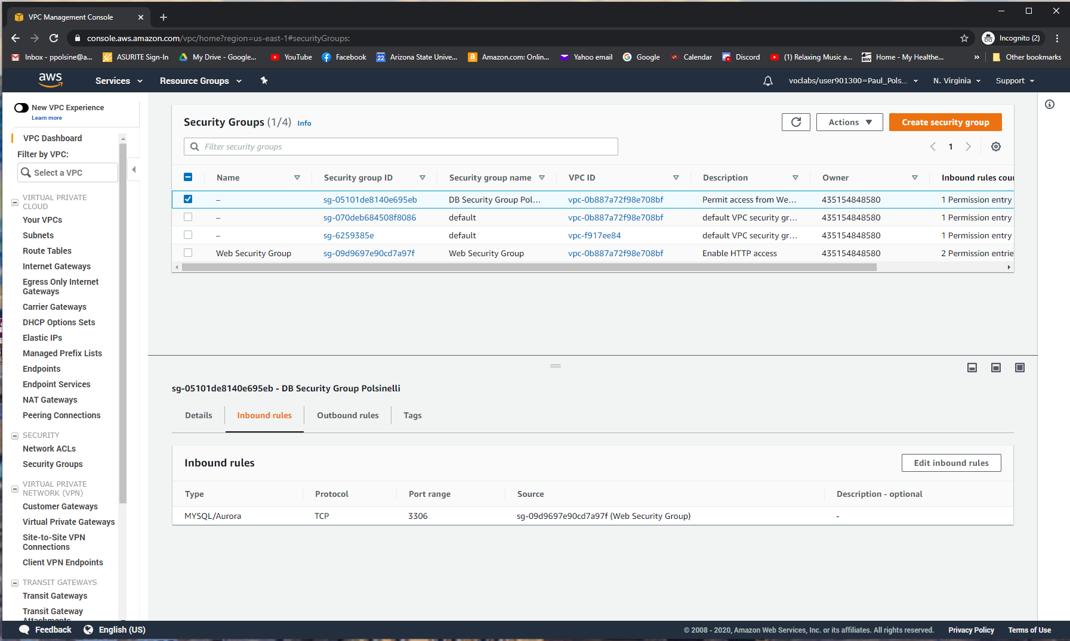

**Figure 2**

*A screenshot of configuration of subnet group.*

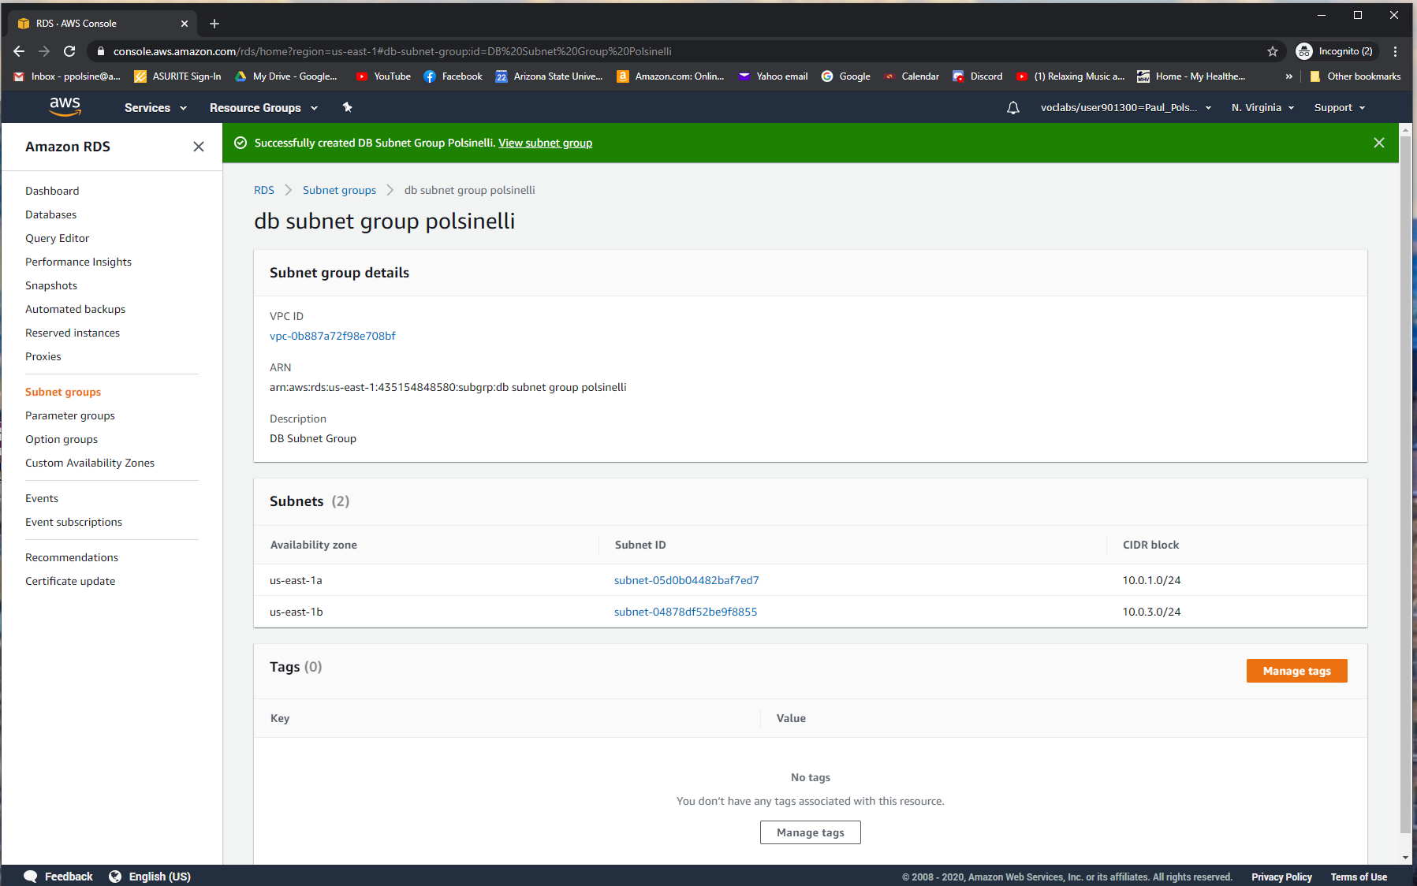

**Figure 3**

*A screenshot of the Endpoint ID.*

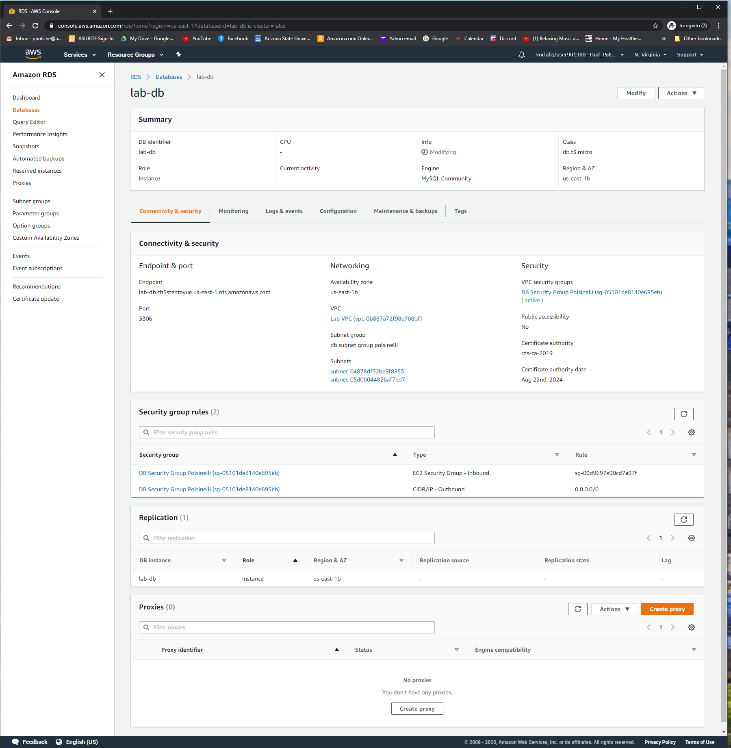

**Figure 4**

*A screenshot of contact with name in address book.*

